**Adult Census Income Prediction**

Wireframe Documentation

Homepage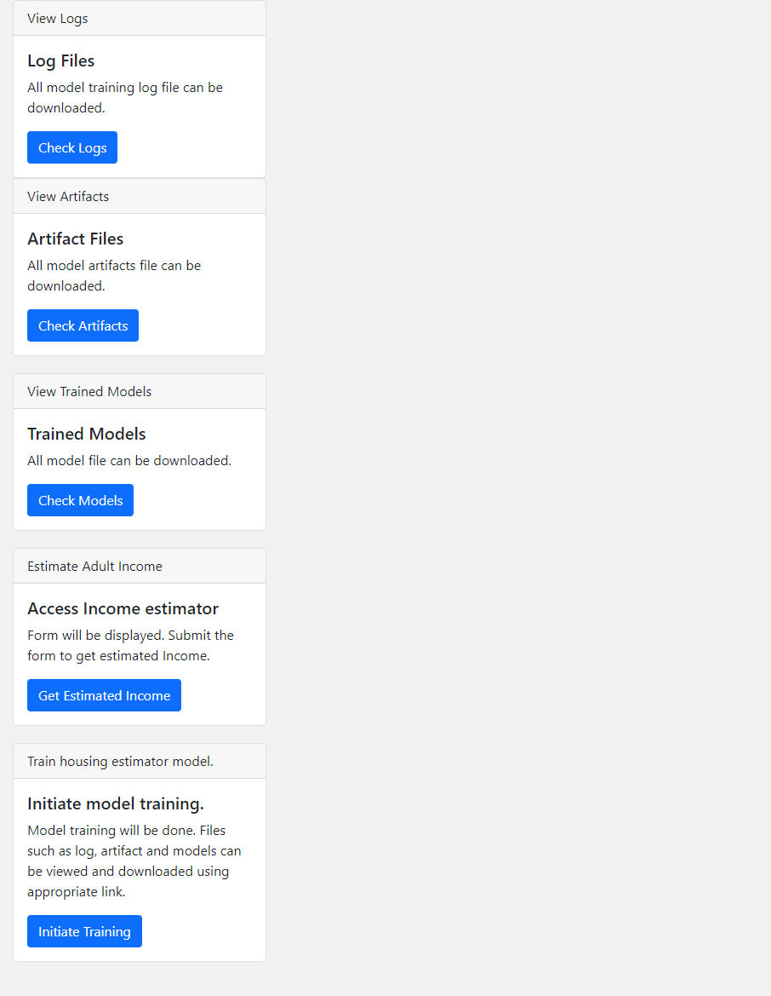

This is the home page.

This is the income estimation form page where user enter data of a person and get prediction about the income of the person.

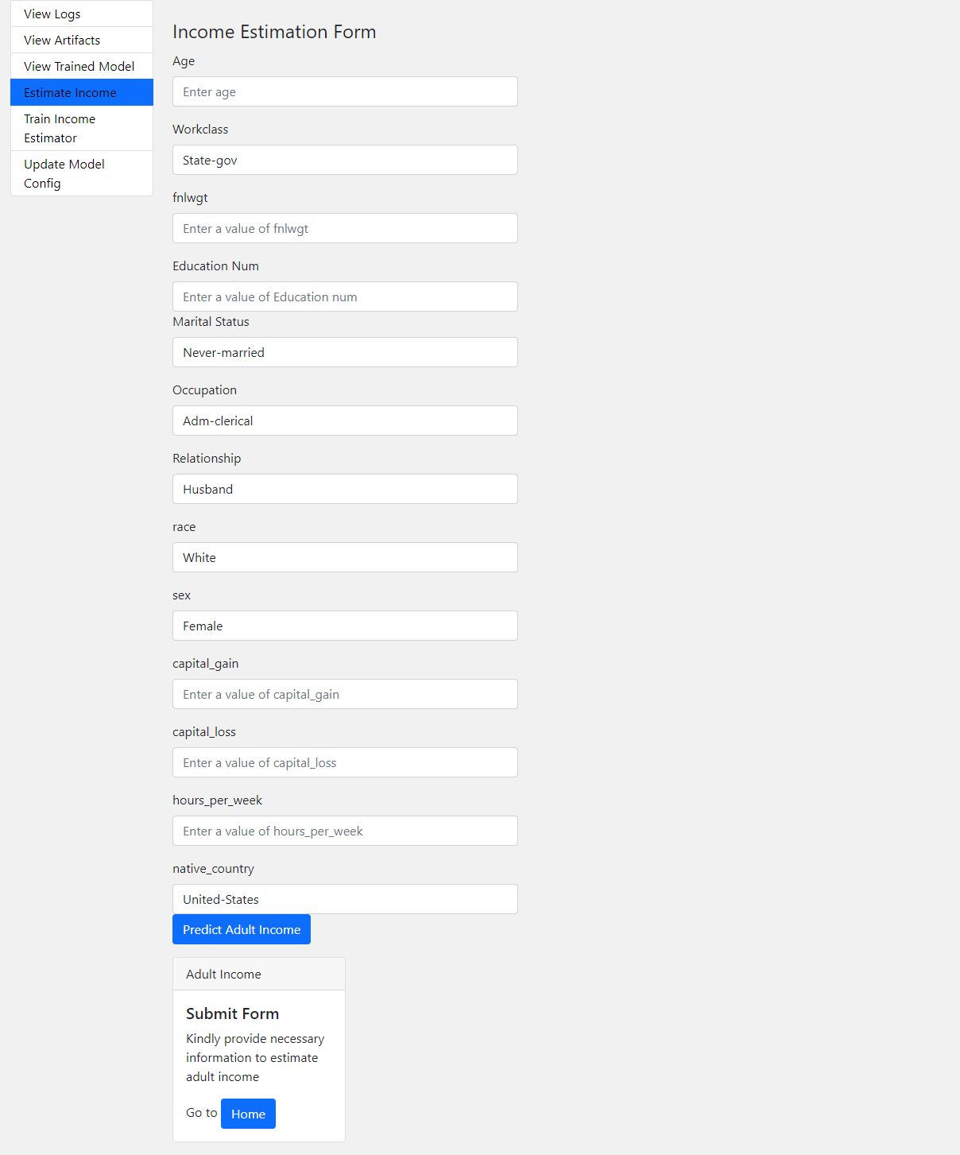

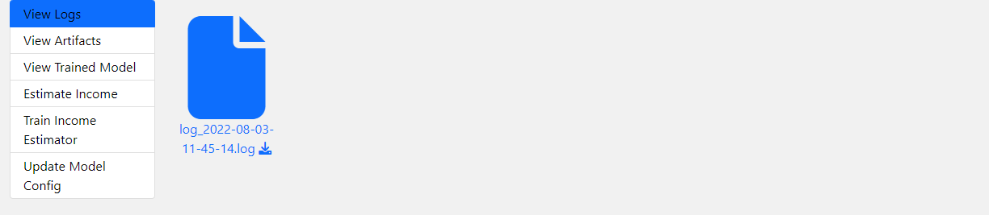

This is logging page where user can see all the logs file.

This is the artifact page where user can all the files.



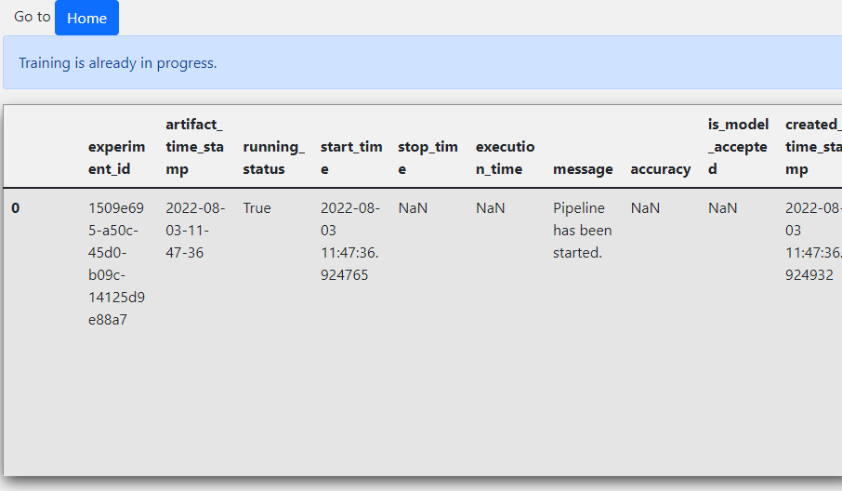This page shows the history about the model.

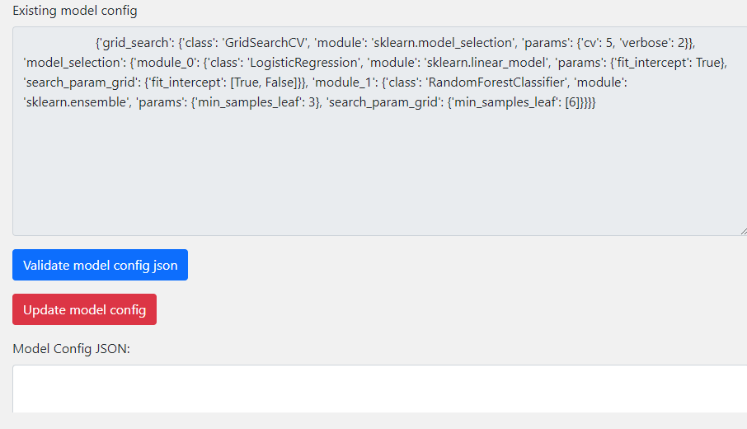This page is for changing hyperparameter tuning with the model.